Daam Dekho Testing Bugs
- Home Page -
A - Language ( This Platform is multilanguage platform )
in to navbar add one more option name is language I want translation language option in to nav heading
1 marathi
2 hindi
3 english
4 kannad
this above language are important
B Search bar ( this bar is using the product searching )
into to that I have facing the error mention the below with error screenshot
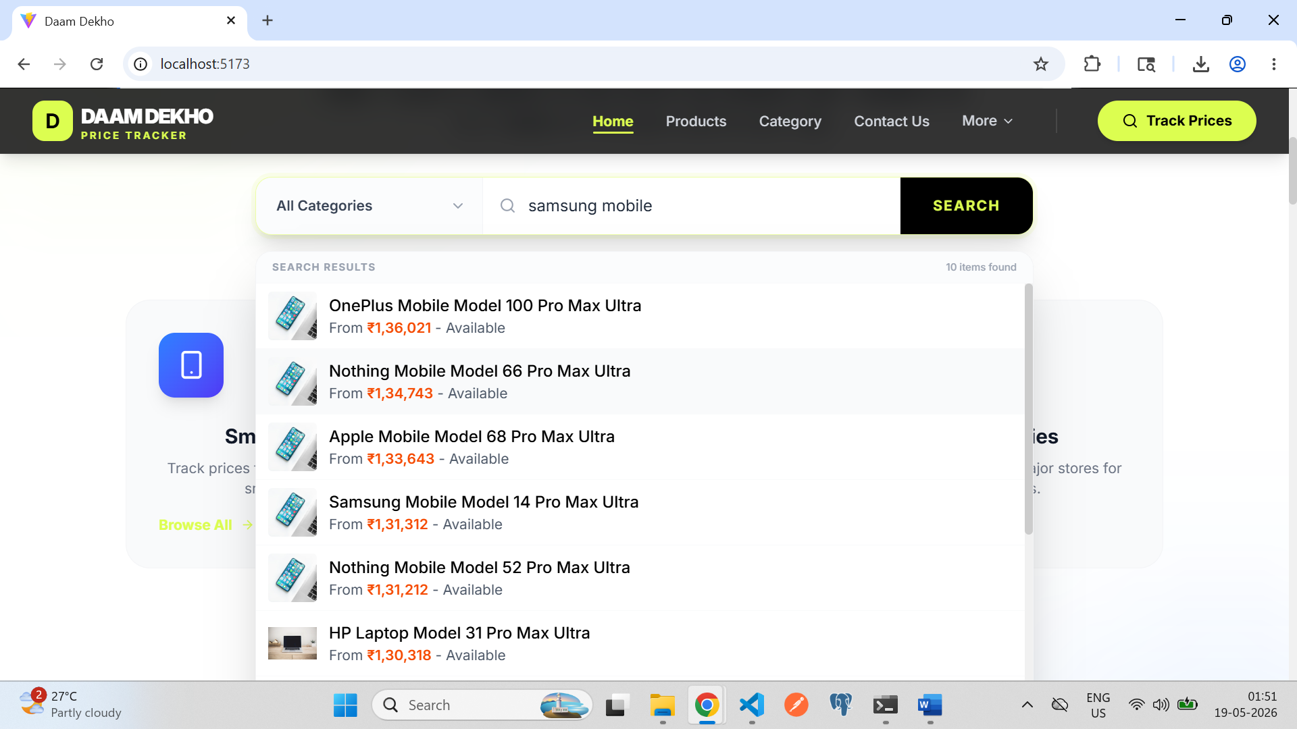
in to above screenshot when I search the Samsung product but in list showing oppo as well as laptop name
please fix it properly I want when I am searching the specific product name and specific product keyword then shown only thes data
C - Tracking live price form
into below screenshot I have facing ui problem
problem - the names of brand is showing black and white color
result – I want the final output is showing the brands images into clean and clear
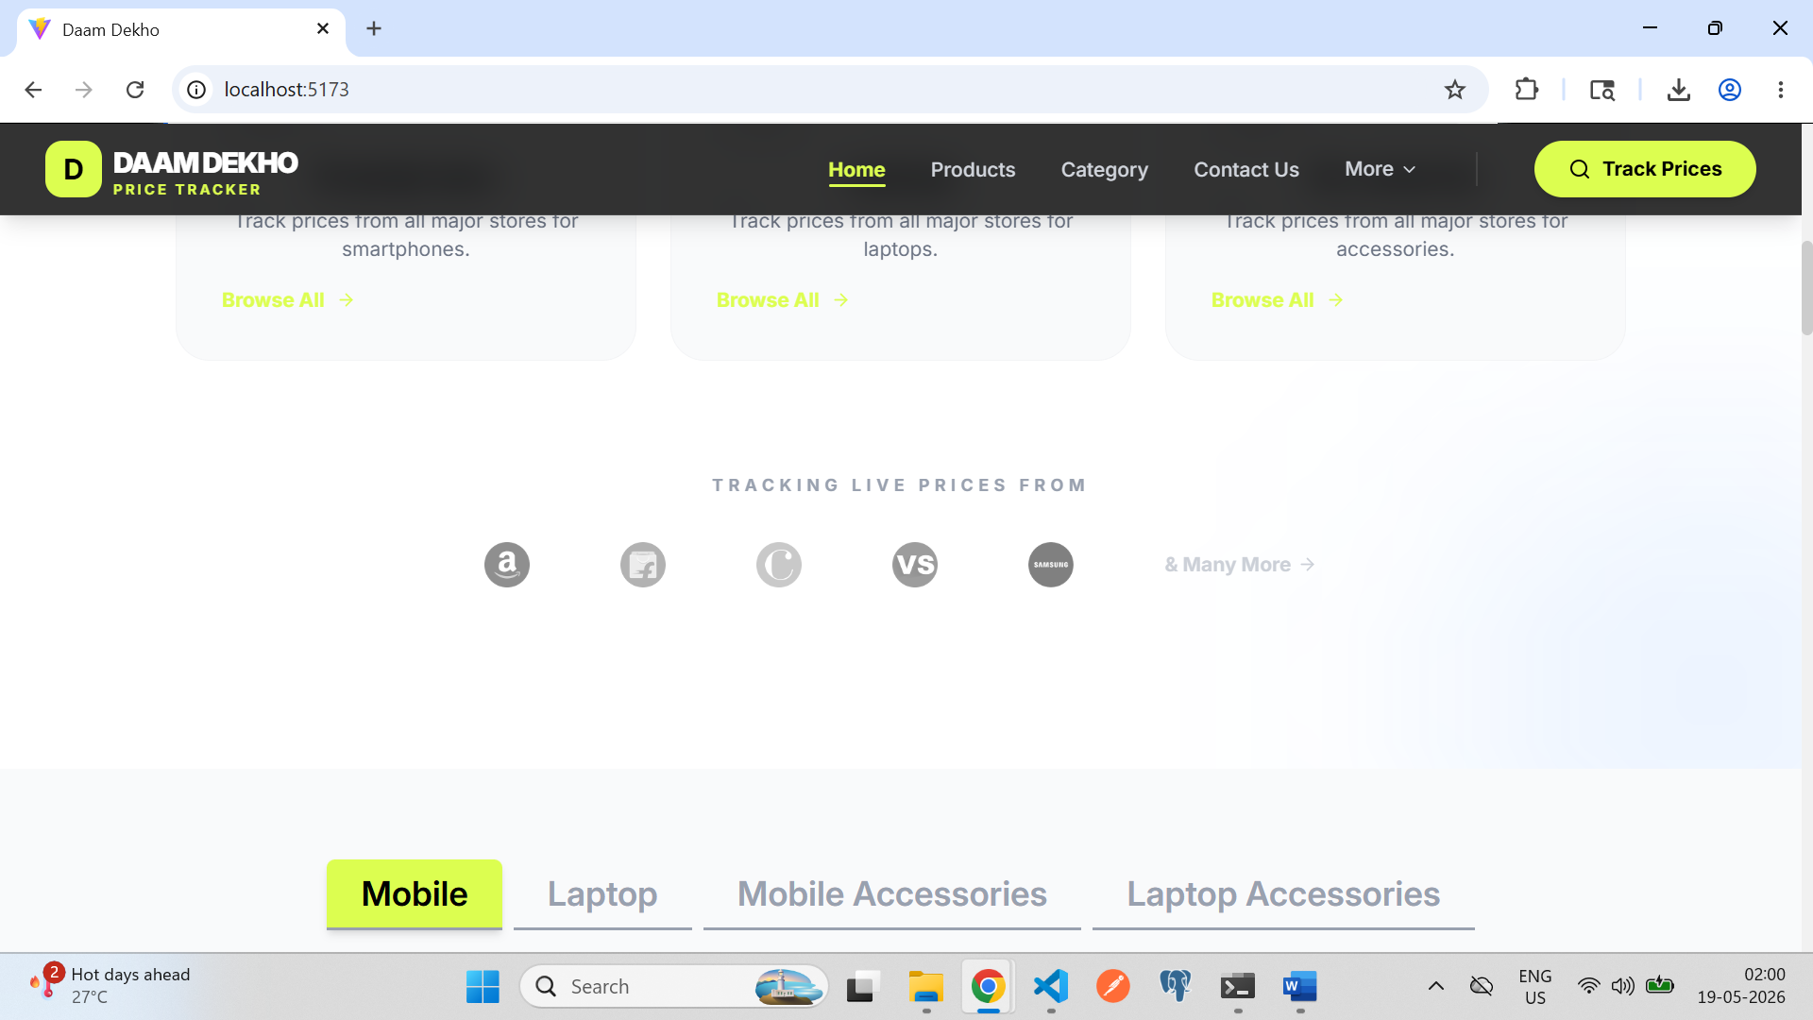

D – compare section
problem - in to compare section when I click on compare now button that time product is didn’t compare (compare product is didn’t working)
result - I want into this section is properly working
I am attached the error screen shot 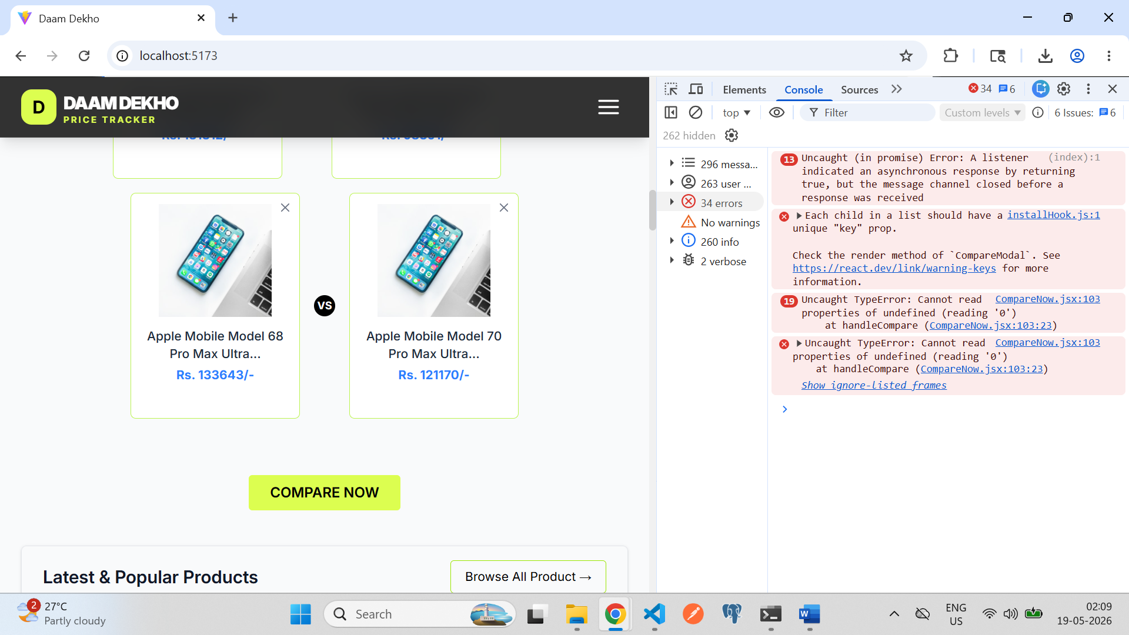
E - Add Some new option
Problem - into below screenshot this popup Is showing into simple design
Result – this information showing is attaractive popup
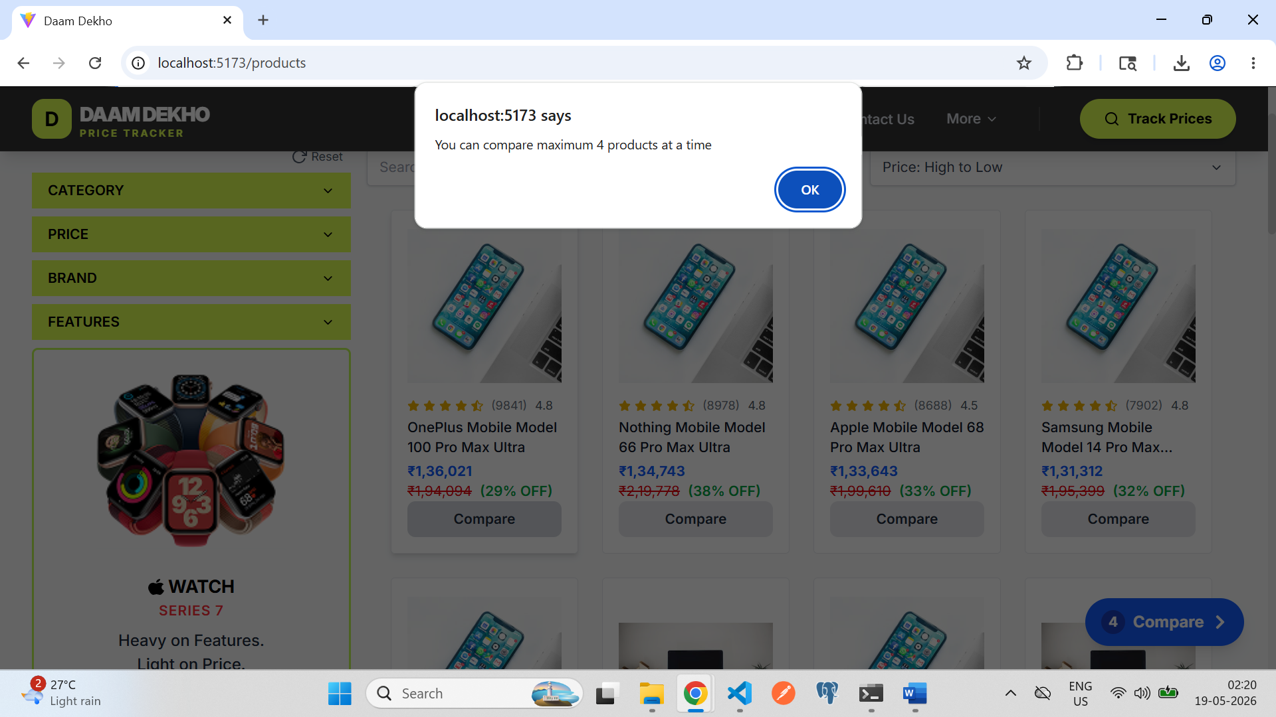
F - Footer Section
Problem - in footer section the footer colur is white they didn’t showing proper
result – please refer navbar as well as complete website pages and fix the color proper

G – Category
In to this page didn’t showing ui proper
I want this cards into horizontal lines
